# 2. OLTP – Load External References – Normalization of Data

## 2.1. Task 01 – Install and expand load of external references T_Languages

Step 1. First of all we’ve crating tablespaces

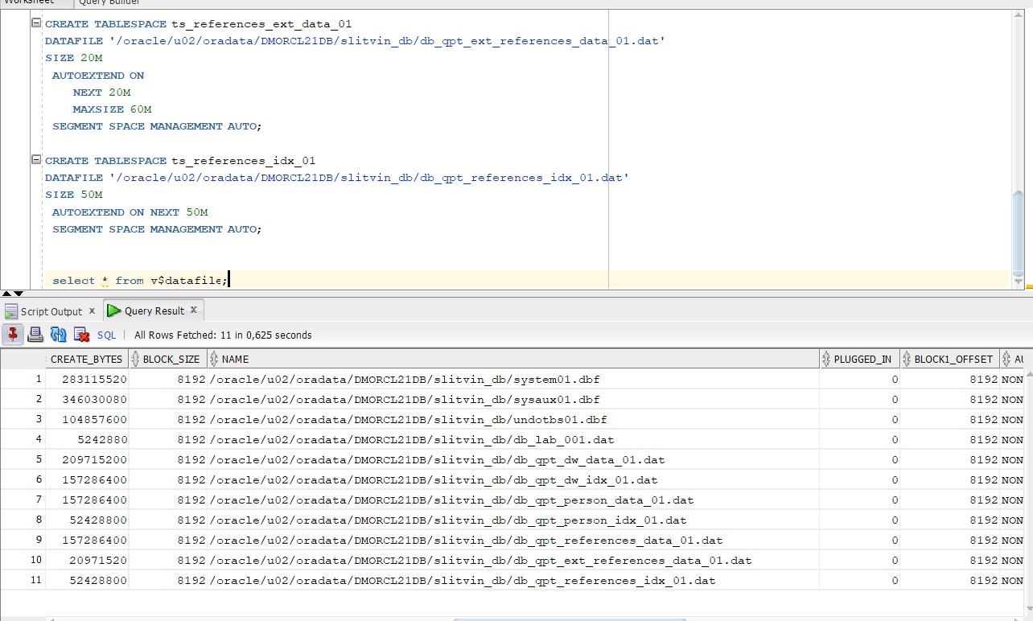

Tablespaces

As you can see all of tablespaces is located in my own directory to reject conflicts with other participants at DataCamp.

I choose manually adding path into datafile, cause ‘alter system’ is doesn’t work correctly.

Step 2. We’ve creating users and granted them access.

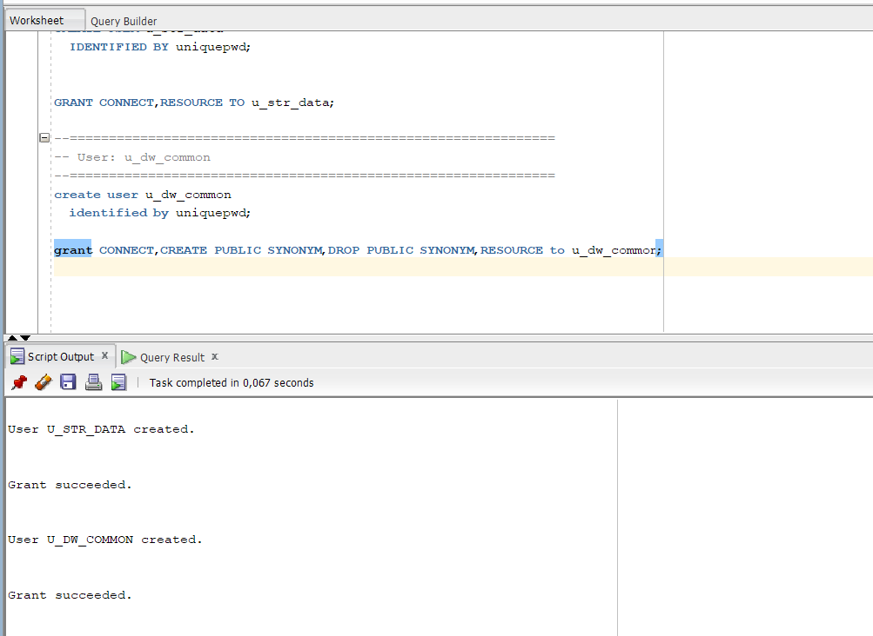

Users creating

Step 3. Create Directory

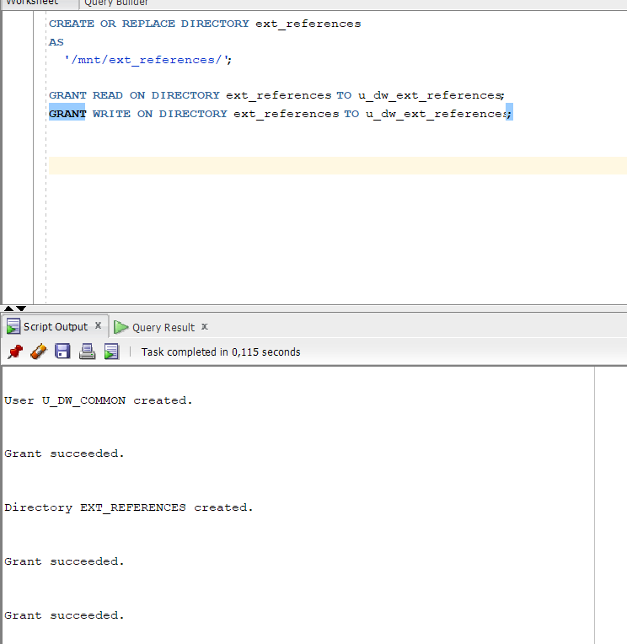

Directory creating

Step 4. Next step is to create ***reference*** folder with next order:

First of all create dimensions around t_languages and after all create t_languages

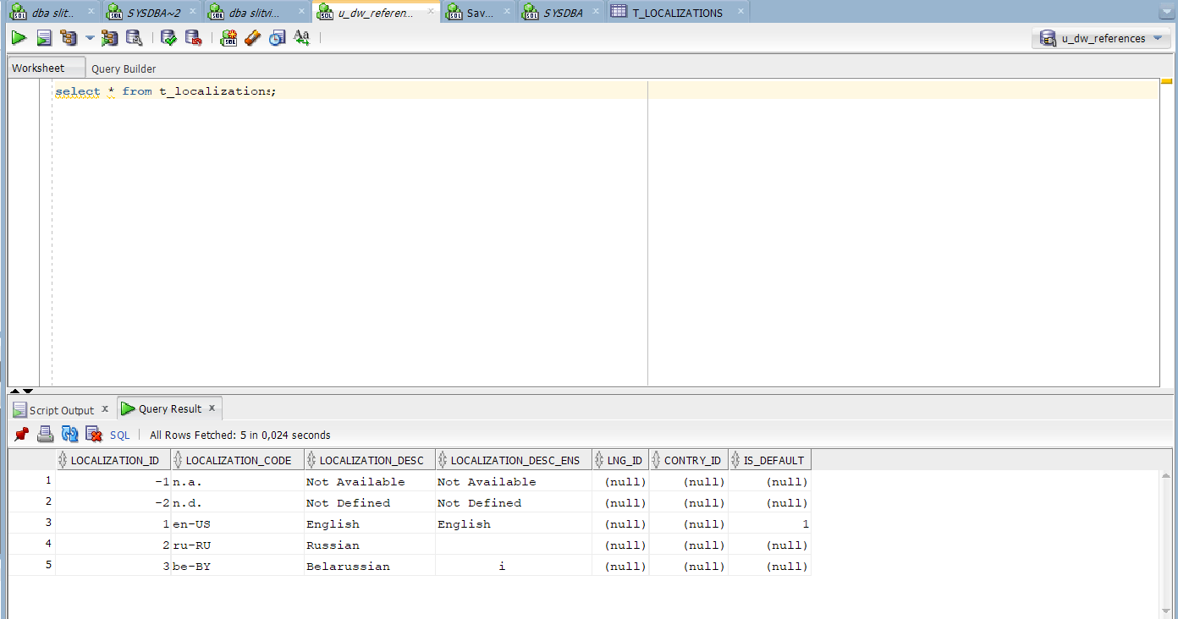

t_localizations

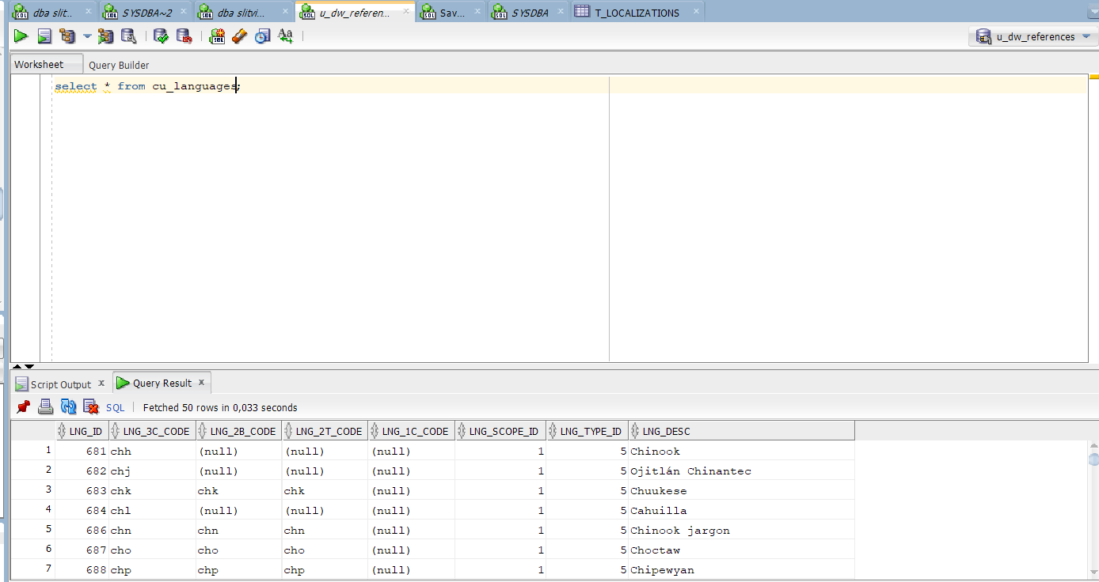

cu_languages

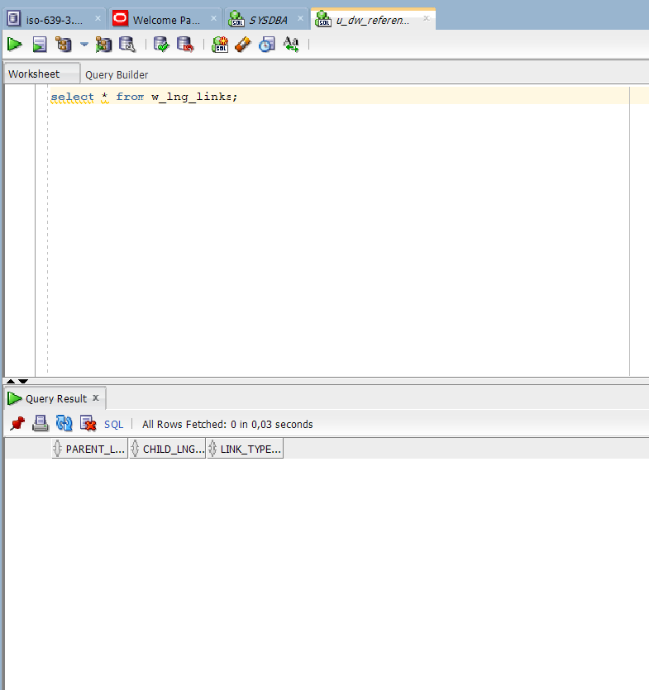

w_lng_links

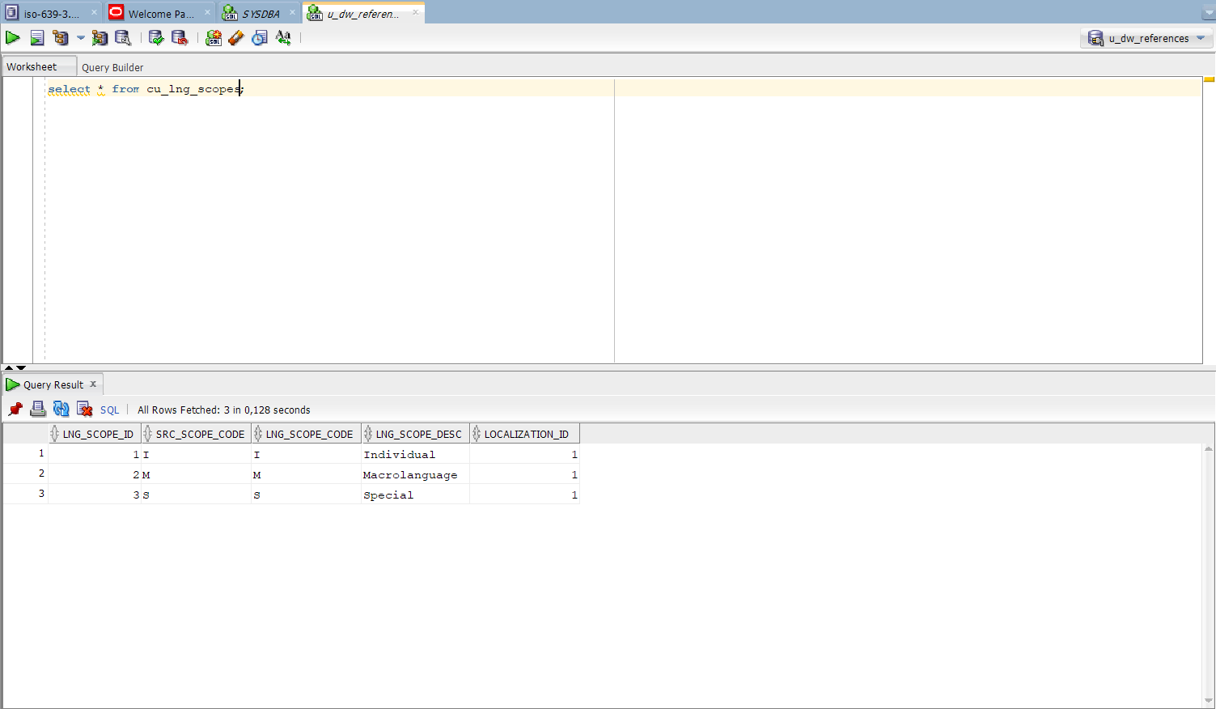

cu_lng_scopes

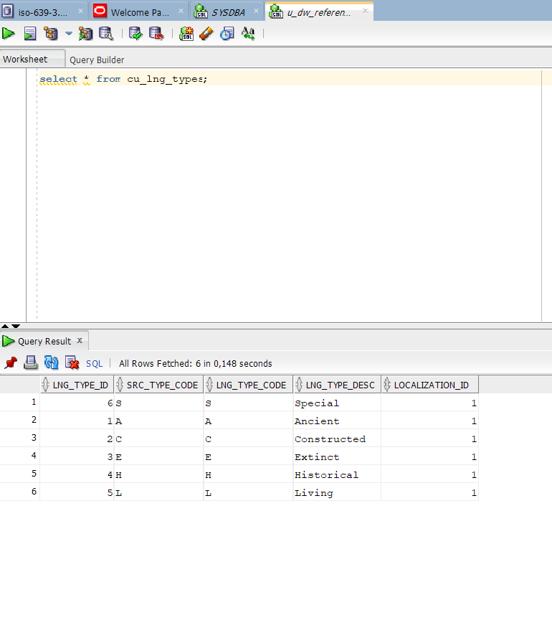

cu_lng_types

All created tables presented on the next screenshot

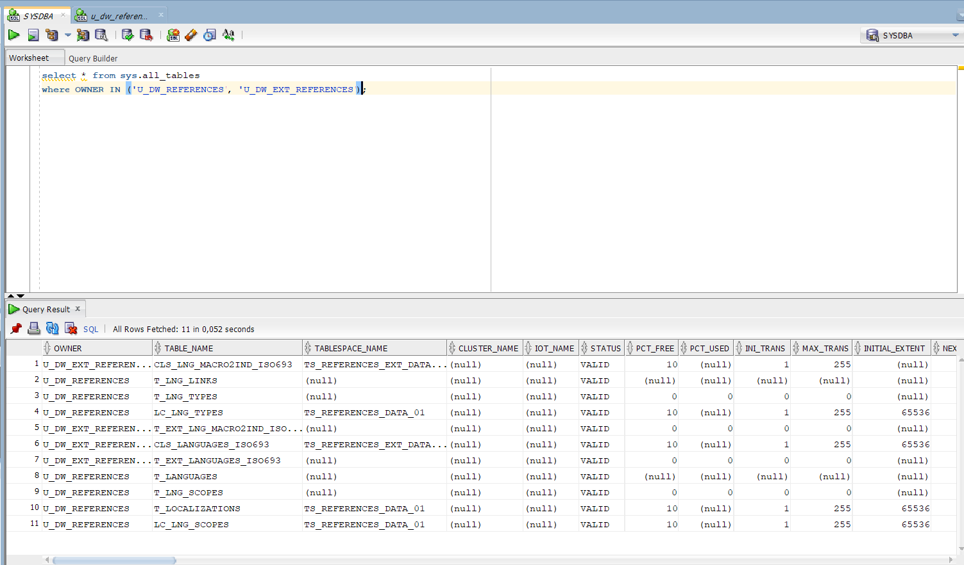

Created tables

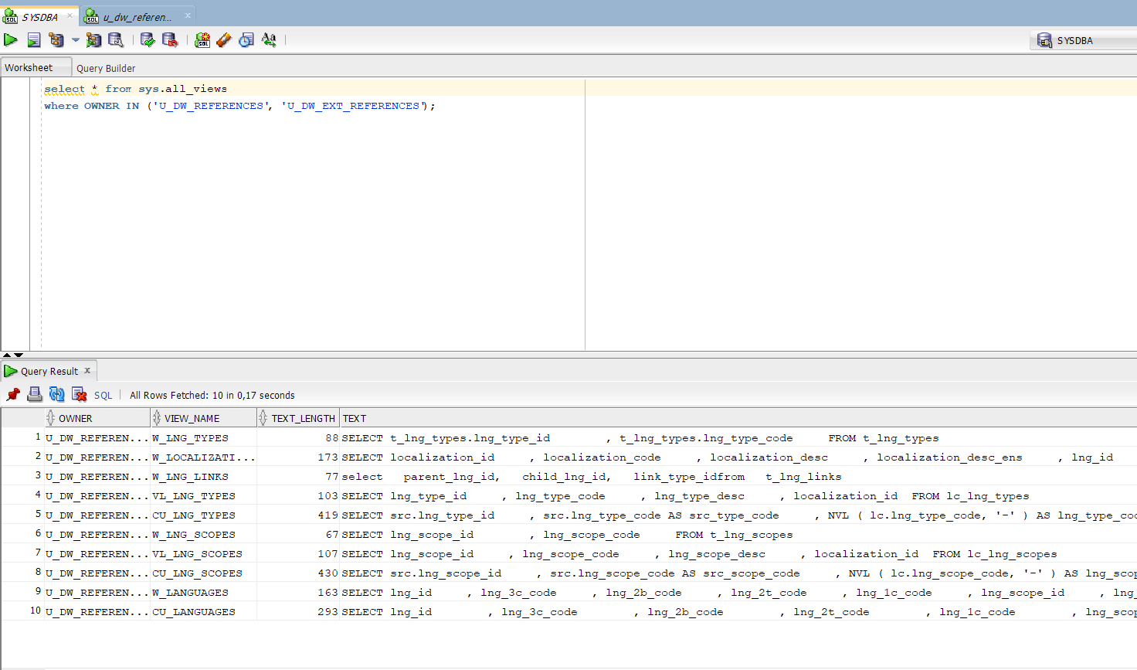

Created views

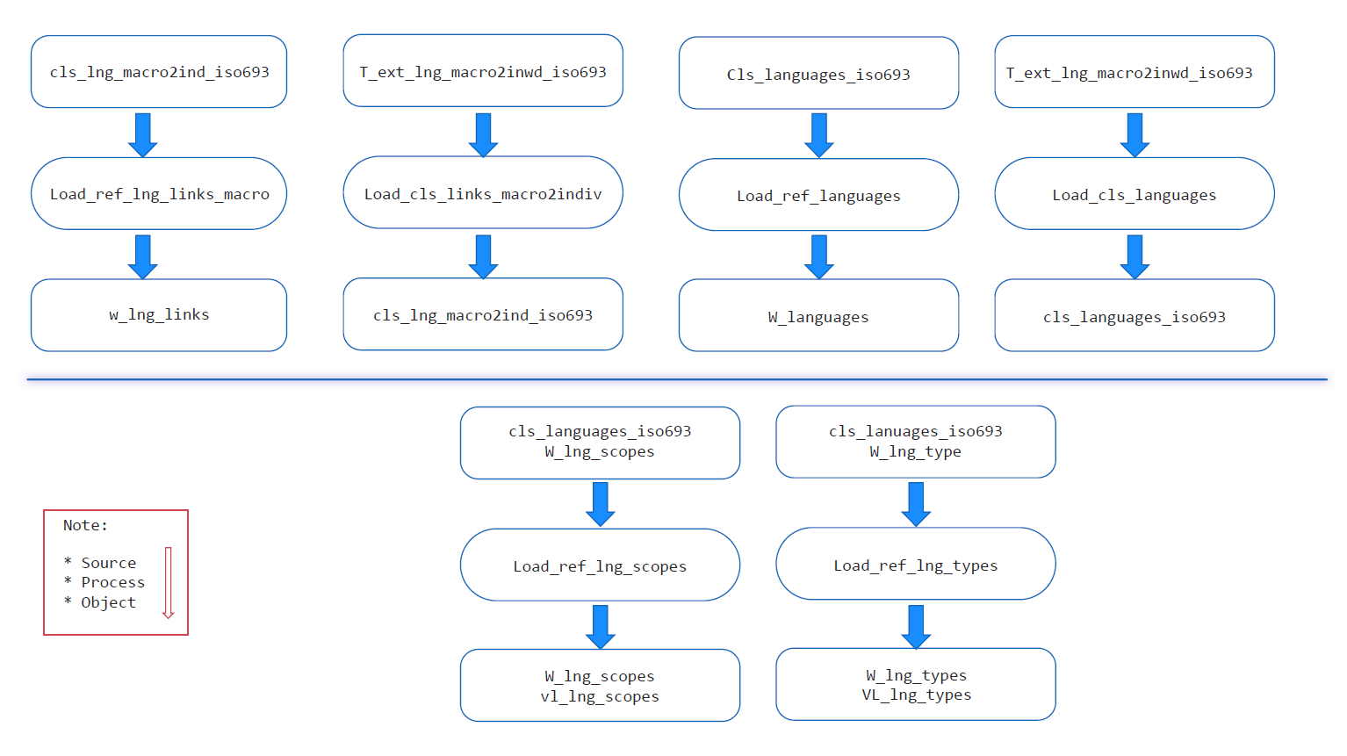

Data flow

## 2.2. Task 02 – Create load process for External references T_Countries

* Create SQL scripts to show All created Tables and Views – Screenshot

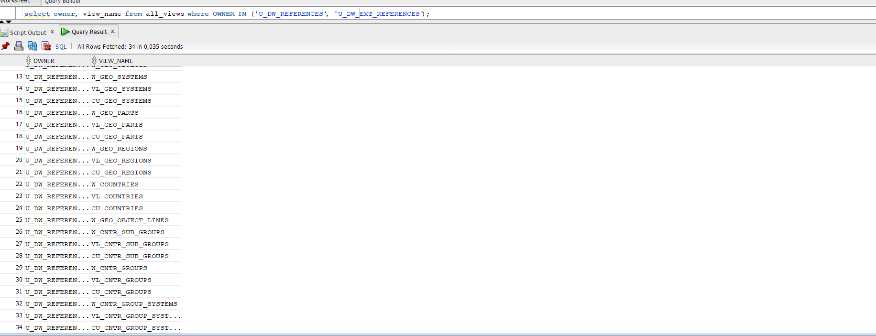

Created views

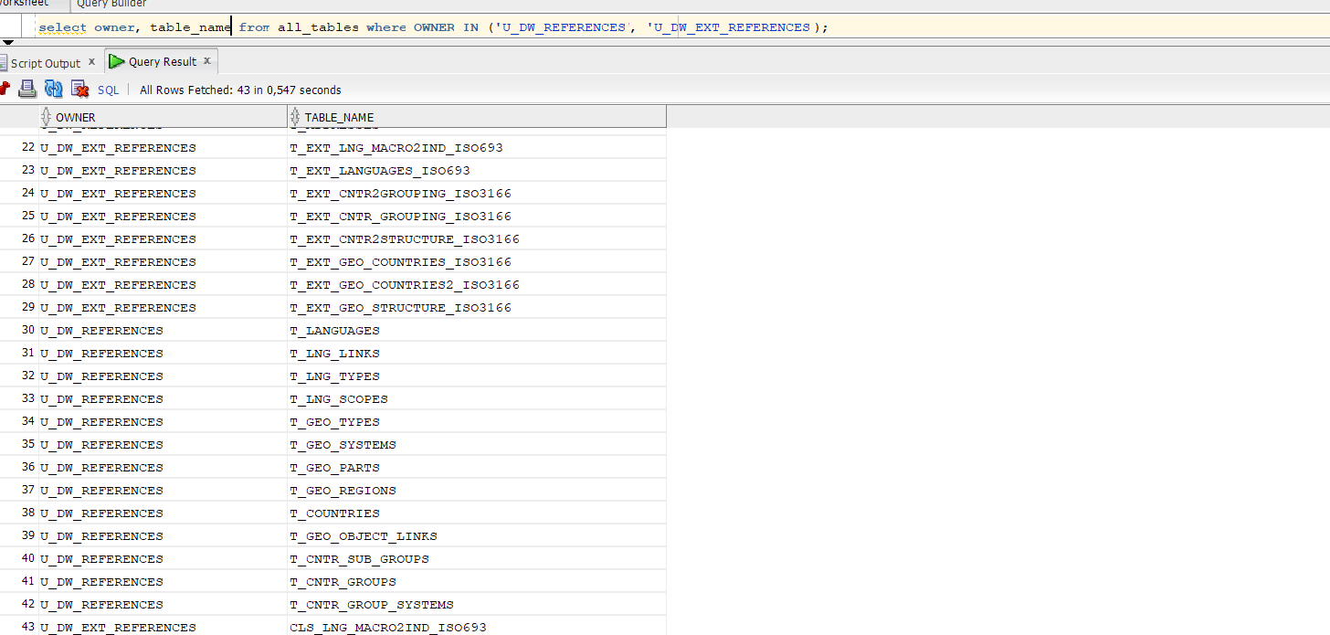

Created tables

* Prepare The Physical Diagram of T_Countries

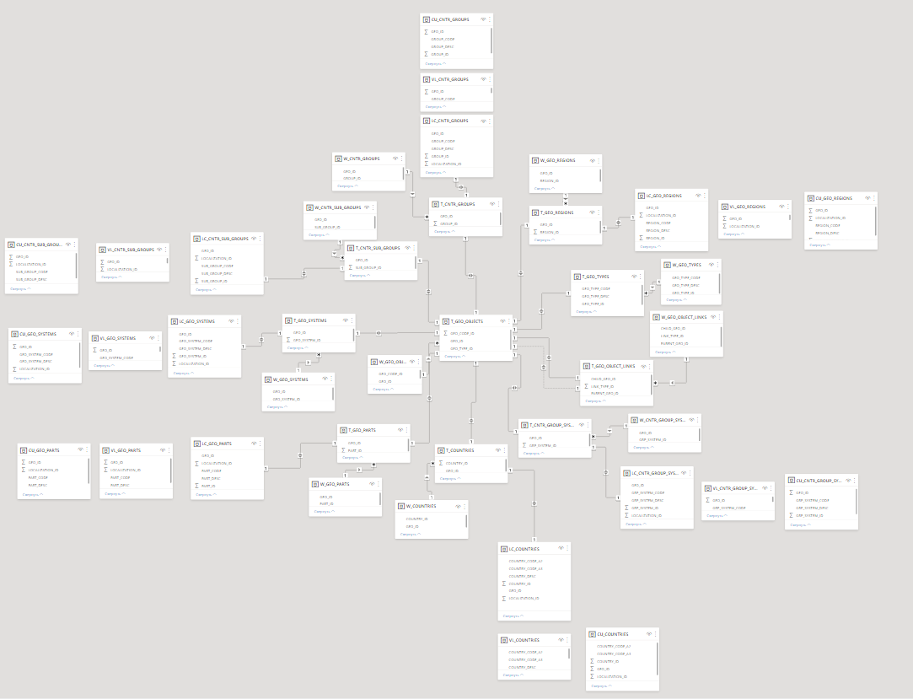

Global Physical Diagram

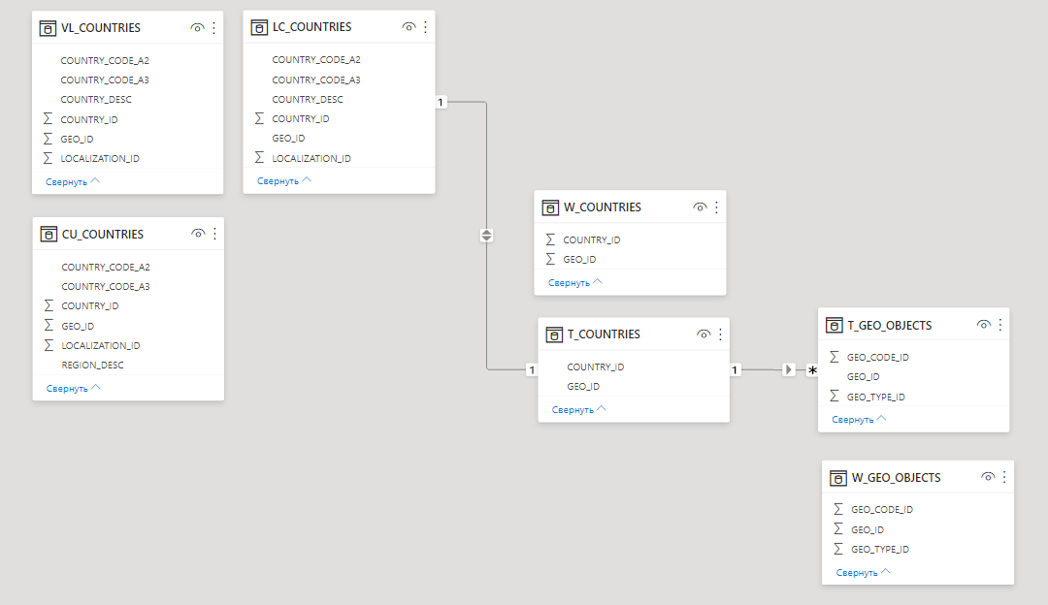

T_Countries

* Create SQL: Showing result of data on main objects:

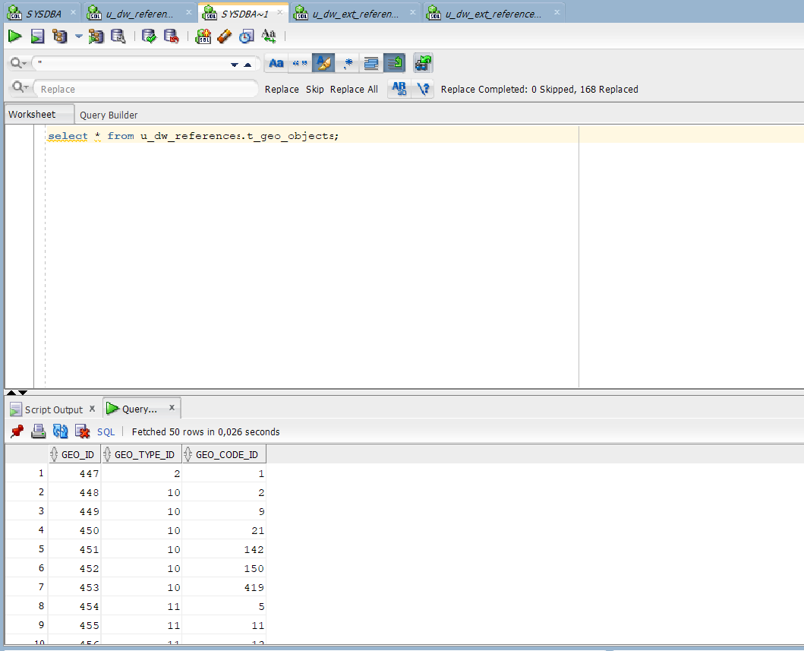

Table geo_objects

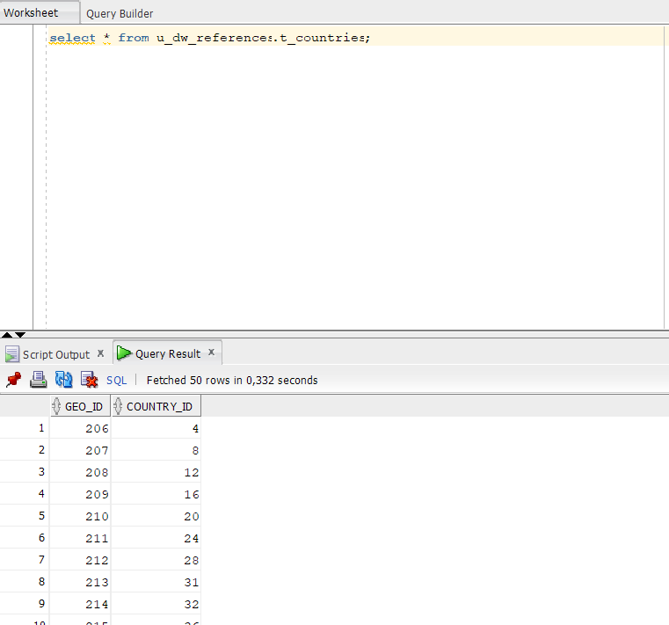

Table t_countries

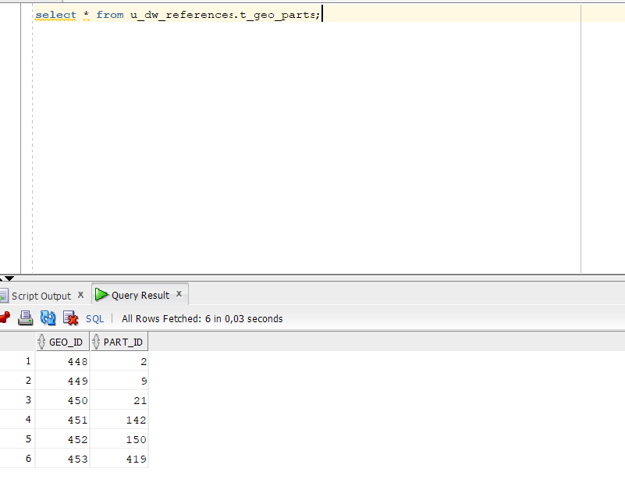

Table t_geo_parts

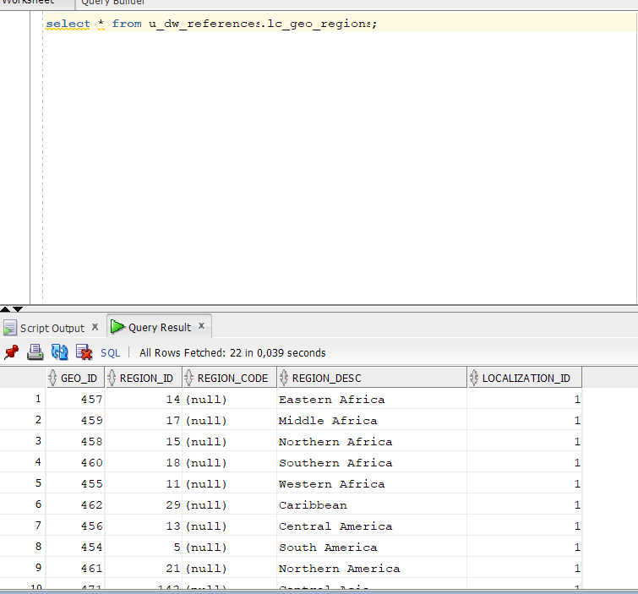

Table lc_geo_regions

As we can see, data was successful inserted.

* Create DataFlow: Sketch Diagram of loading external References (MS Visio, MS Paint, MS Word, etc.)

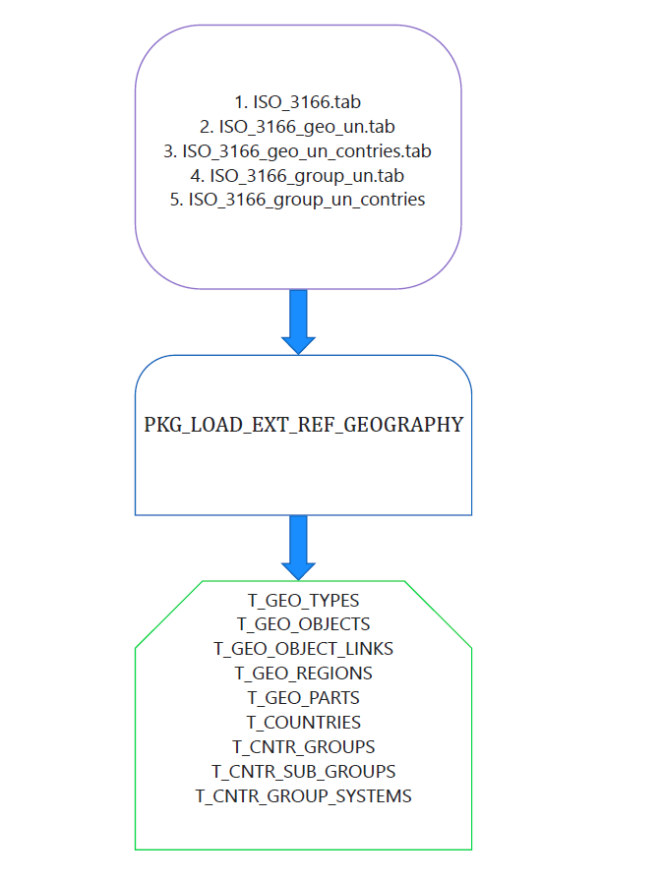

DataFlow Diagram

# 3. OLAP – Business analyses task